**A Synopsis**

**Online Car Rental Service**

*Submitted in partial fulfilment of the requirements*

*for the award of the degree of*

**Bachelor of Computer Application**

To

**Guru Gobind Singh Indraprastha University, Dwarka**

*Under the guidance of* **Submitted by:**

**Ms. Ritika Kapoor** Piyush (02324002018)

**BCA Department**  Mayank (01824002018)

BCA 6th Semester

 2nd Shift

**2020-2021**

**TRINITY INSTITUTE OF PROFESSIONAL STUDIES**

(Affiliated to Guru Gobind Singh Indraprastha University, Delhi)

Ranked “A+” Institution by SFRC, Govt. of NCT of India

Recognized under section 2(f) of the UGC Act, 1956

NAAC Accredited “B++” Grade Institution

**INDEX**

|  |  |  |
| --- | --- | --- |
| S.no | Topic | Sign |
| 1 | Introduction |  |
| 2 | Methodology |  |
| 3 | Requirements |  |
| 4 | Modules |  |
| 5 | ER Diagram |  |
| 6 | Use Case Diagram |  |
| 7 | Level 0 DFD |  |
| 8 | Level 1 DFD |  |
| 9 | Level 2 DFD |  |
| 10 | Future Scope |  |
| 11 | Conclusion |  |
| 12 | References |  |

**Introduction**

This project is designed so as to be used by Car Rental Company specializing in renting cars to customers. It is an online system through which customers can view Available cars, register, view profile, and book car. The advancement in information Technology and internet penetration has greatly enhanced various business process and communication between companies (Service Provider) and their customer of which var rental industry is not left out.

The main objective of the application car Rental System require a temporary vehicle, for example those who do not own their own car, or owners of damaged or destroyed vehicles who are awaiting repair or insurance compensation or travellers who are out of town.

**The online Car Rental System is developed to provide the following Services:**

1. Enhance Business Process: To be able to use the internet technology to project the rental company to the global world instead of limiting their services to their local Domain alone.
2. The Content management system (CMS) for managing the content of the cars.
3. The Data Security System.
4. Reporting of the cars, Bookings, etc.
5. Customer Registration: A registration portal to hold customer’s details, monitor their Bookings and used same to offer better and improve services to them.
6. Online Vehicle Registration: A tool through which customers can reserve available cars online prior to their expected pick-up date or time.

**Methodology**

The Car rental system is developed for customers so that they can book their vehicle from the customers through filling their details. A customer being registered in the website has the facility to book a vehicle which he requires.

The proposed system is completely integrated online systems. It automates manual procedure in the effective and efficient way. The automated system facilitates customer and provides to fill up details according to their requirements. It includes type of vehicle they are trying to hire. The purpose of a system is to develop a website for the people who can book their vehicle along with requirements.

Here, User has to Login To book a car. The user can search for cars easily and book. For bookings, the user has to provide information such as Booking Dates and Text Message. All car details are provided and it also includes Car’s feature and Overview. The user can also post their Testimonials and the user can update their Profile as well as passwords anytime they want from the site. Admin can Add/Manage car brands, manage vehicles, bookings, testimonial, pages and many more.  It’s easy to operate and understand by users. This site makes customers easy for car rental. The design is pretty simple and the user won’t find it difficult to understand, use and navigate.

The web administrator is the one who has full control and authority to control the privilege and update the propose system from time-to-time. In addition, they also required to ensure that the different type of user access via their permitting level.

**Requirements**

**Software Requirements:**

* Web Server (preferably Apache)
* PHP (at least 5.2)
* MySQL
* Curl

**Hardware Requirements:**

* 4 Gigabytes of RAM
* 500 Gigabytes of HDD
* i3 Processor 5th Generation

**Modules:**

1. **Admin Module**

Admin module will help us organize the most important functionality of managing the user, cars, bookings, and all. All work done by employees are included under Admin Module.

1. **Customer Module**

Customer module is the most important module of this project which helps Customer Sign up/ Login and After that customer can book the available cars with the respective date. Customers can also Update their profile.

1. **Feedback Module**

Feedback module is used to take feedback and show the testimonials on the webpage so that user can rate the service.

1. **Payment Module**

By Connecting the payment gateway user can pay directly from website rather than paying cash at the counter.

1. **Staff Module**

Staff members can approve and reject the Request of the customer after checking the availability of the vehicle and after verifying that the customer is real and not a fake customer

**Entity Relation Diagram**

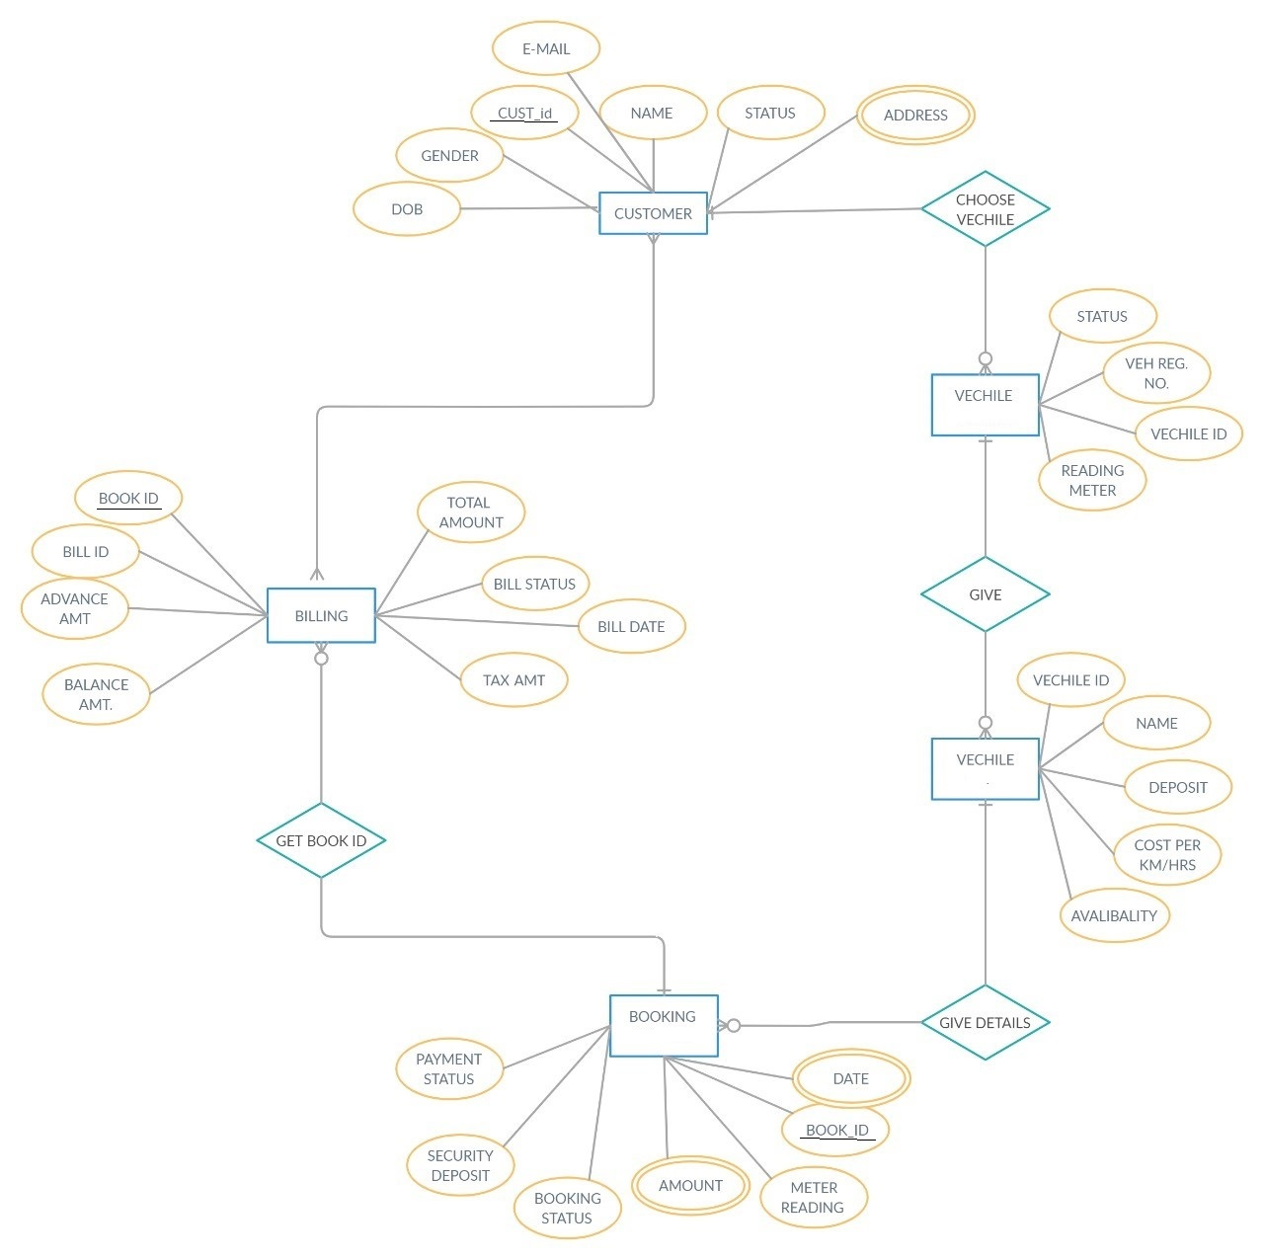

**Use Case Diagram**

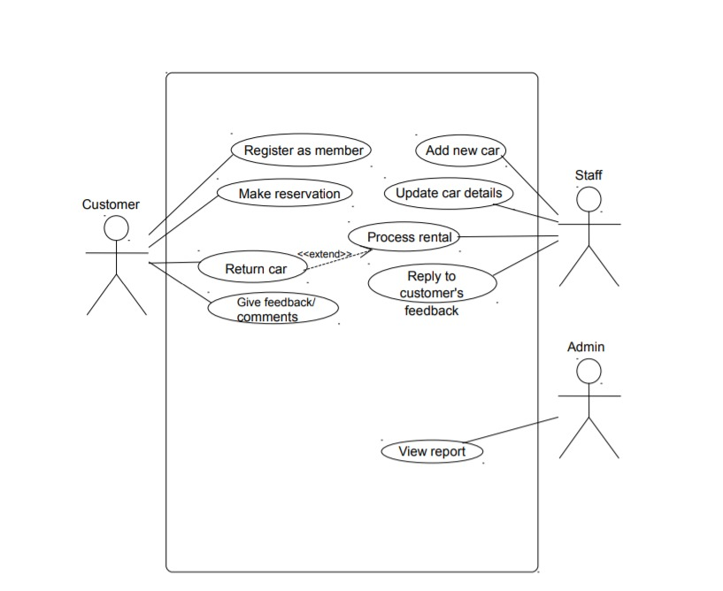

**Level 0 DFD**

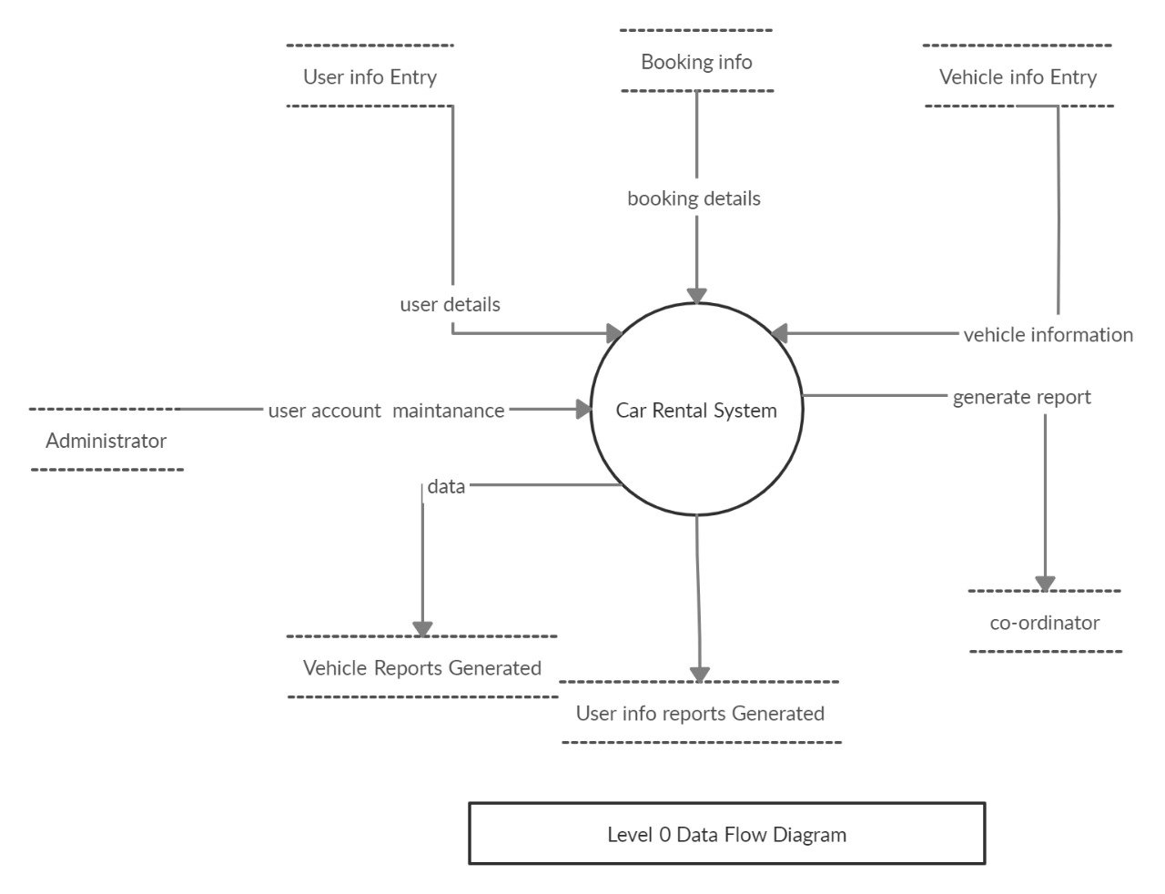

**Level 1 DFD**

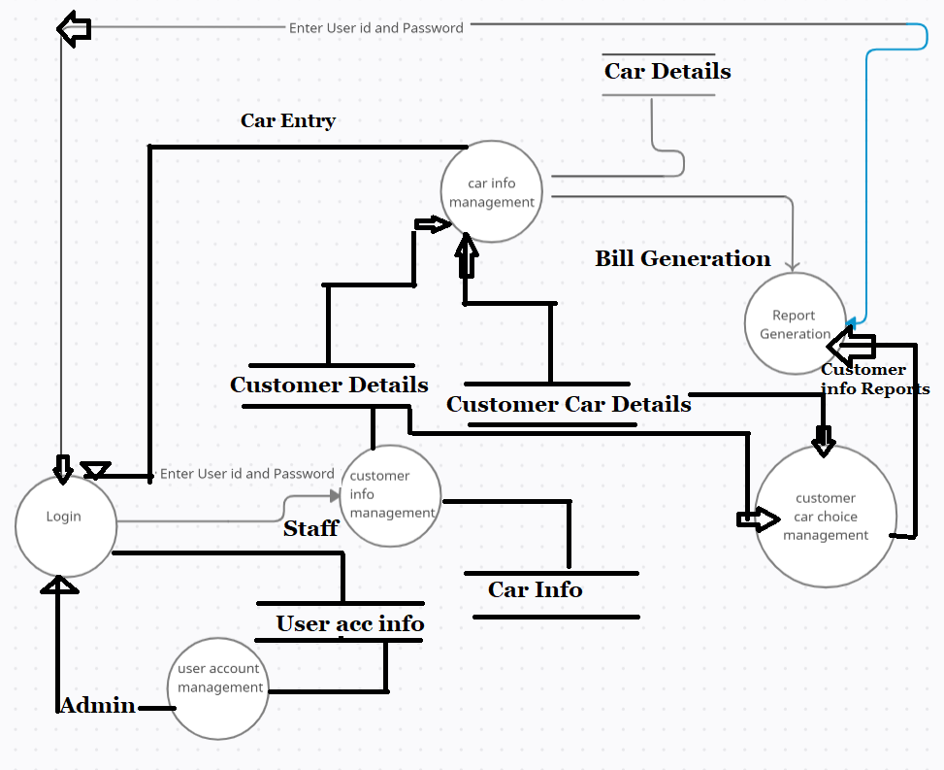

**Level 2 DFD**

1. **User Account Maintenance**

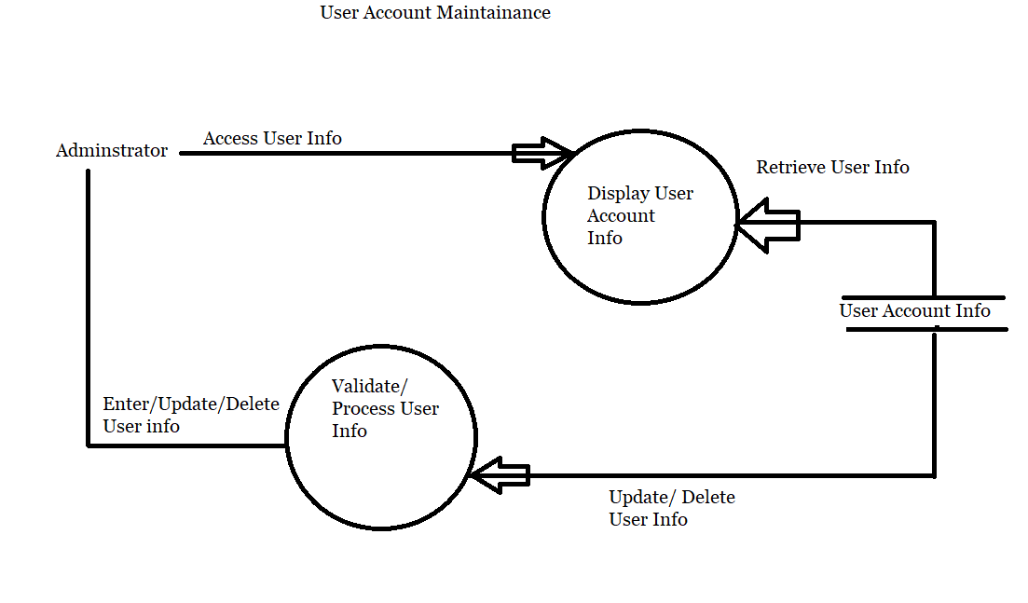

1. **Login**

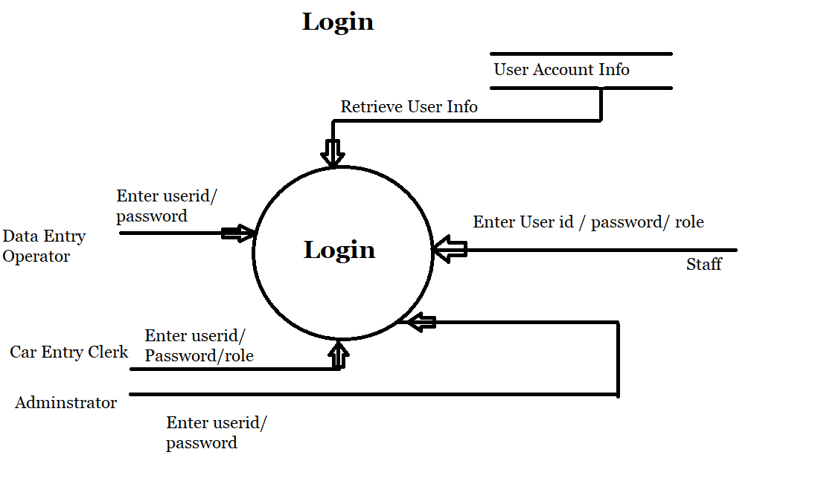

1. **User Information Management**

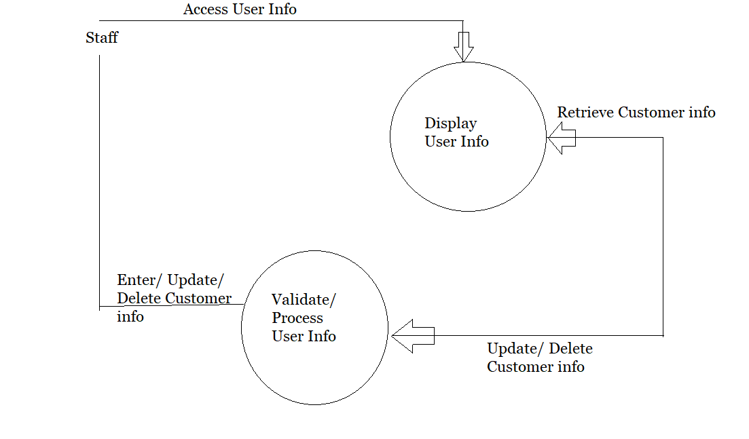

1. **Car information Management**

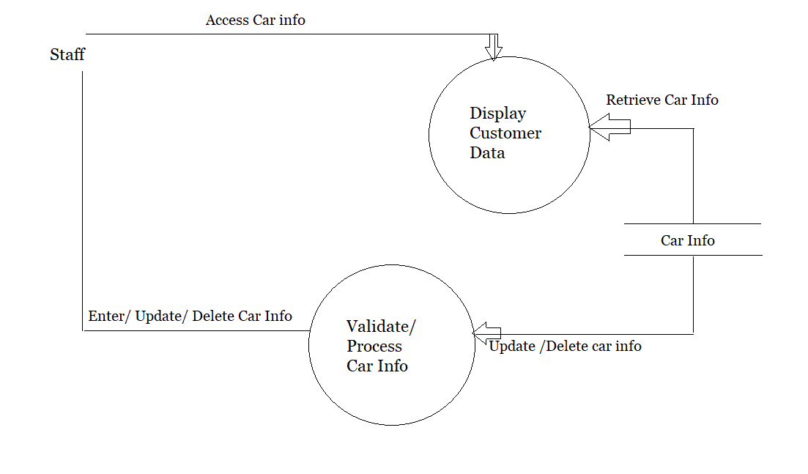

1. **Customer’s car choice management**

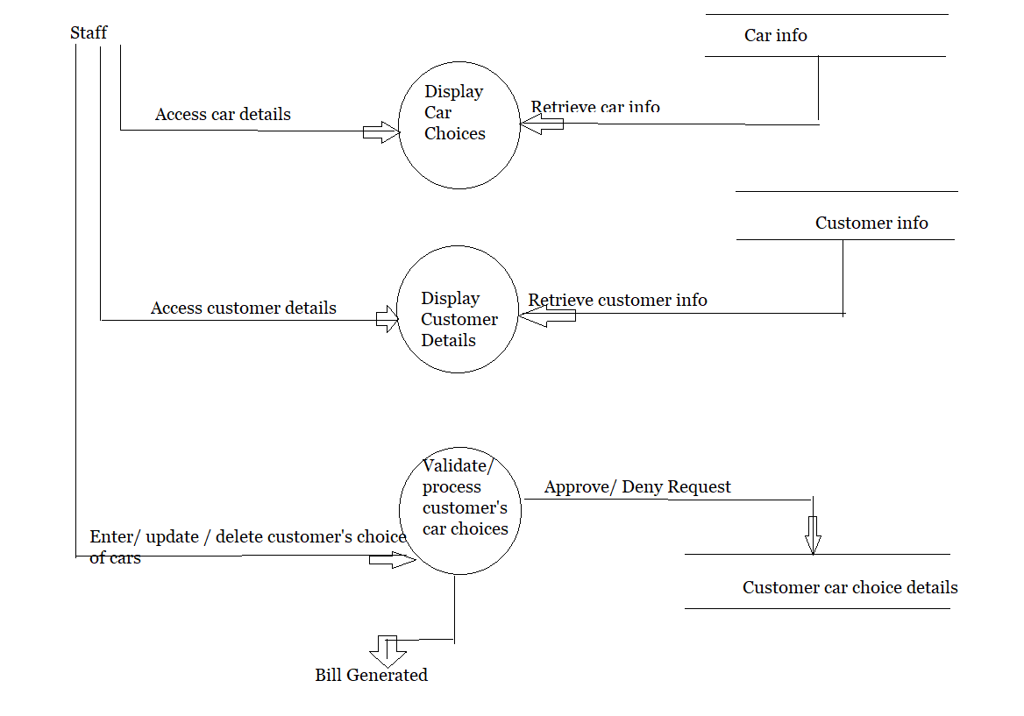

**Future Scope**

The objective of the proposed Online Car Rental System, the users are able to enter the company’s website for searching and reserving their favourite cars easily through the Internet and it can be access anywhere anytime in the world. Hence, the company is able to improve their customer satisfaction level, increasing efficiency by provides better services to their customer.

In near future, we are planning to hire cars daily bases. So that clients can give their car to the customer on daily bases. We are planning to add new feature i.e. pay after the trip. We are working to increase automation in the system to increase user experience great.

It is Great for the future perspective that someone who is willing to earn money from their cars they can also join Car Rental Company as they can lend their cars to earn money.

**Conclusion**

I conclude that We are making this website to help the society and people who want to travel and they don’t have any car.

We provide Cars on demand on rental basis to customers for travelling. We also provide luxury cars to Premium Customers. You can rent car for outstation trips also like Manali, Kasol, Shimla, You’ll love our service and please provide the testimonials.

**References**

**Books:**

1. Software Engineering (Third Edition) by KK Aggarwal and Yogesh Singh

**Links:**

1. [**https://tailblocks.cc/**](https://tailblocks.cc/)
2. [**https://tailwindcss.com/**](https://tailwindcss.com/)
3. [**https://animate.style/**](https://animate.style/)
4. [**https://stackoverflow.com/questions/1053424/how-do-i-get-php-errors-to-display**](https://stackoverflow.com/questions/1053424/how-do-i-get-php-errors-to-display)
5. [**https://stackoverflow.com/questions/tagged/css**](https://stackoverflow.com/questions/tagged/css)